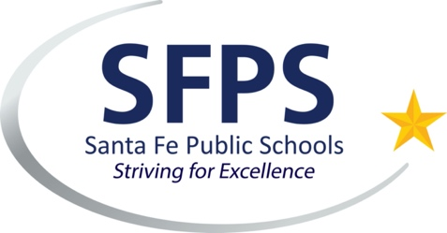
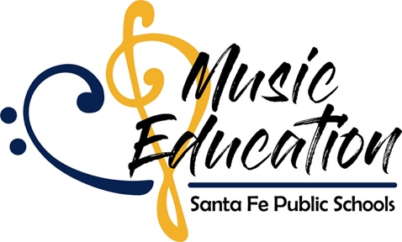

Posting for Open Position

2021-2022
Santa Fe Public Schools
Santa Fe, New Mexico
Accepting Applications - Elementary Music
Bachelor's/Master’s Degree music education, emphasis elementary music. Working knowledge of pedagogy, voice/instruments, methods, literature. Multiple performances, participation in state/local festivals. Strong organization skills, interaction with broad range of supporters. Inspire student/community enthusiasm, bolster programs. NM state certification required with endorsement or ability to obtain one.
Full time position
Sweeney Elementary, General Music, 1.0 (includes benefits)
Positions open until filled
Applications: www.sfps.info
Support: recruiting@sfps.k12.nm.us
April Pickrell
Music Education Coordinator
apickrell@sfps.k12.nm.us

Music Education Coordinator 🎵
Santa Fe Public Schools
1300 Camino Sierra Vista
Santa Fe, NM 87501
505-467-2513

